EXP NO 1: CREATE A SIMPLE CLOUD SOFTWARE APPLICATION AND PROVIDE IT AS A SERVICE USING ANY CLOUD SERVICE PROVIDER TO DEMONSTRATE SOFTWARE AS A SERVICE (SAAS). DATE: 11-02-25 AIM: To create a simple cloud software application(HOSPITAL MANAGEMENT) and provide it as a service using any cloud service provider to demonstrate software as a service (saas).
PROCEDURE:
STEP1: GOTO ZOHO.COM
STEP 2: LOGIN TO THE ZOHO.COM
STEP 3: CREATE APPLICATION NAME
STEP 4: SELECT ONE FORM AND GIVE FORM NAME
STEP 5: DRAG AND DROP THE DETAILS
STEP 6: ENTER ALL DETAILS IN THE FORM AND GIVE SUBMIT
STEP 7: CLICK ON ALL DETAILS AND CHECK FOR THE DETAILS.
STEP1: GOTO ZOHO.COM

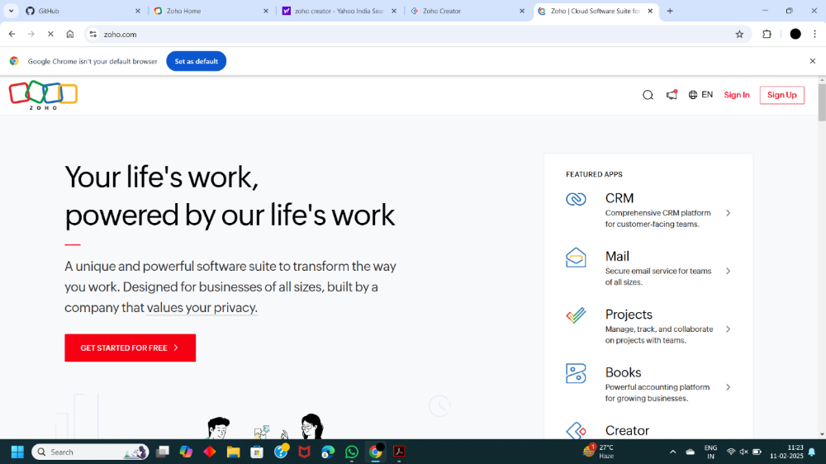
STEP 2: LOGIN TO THE ZOHO.COM
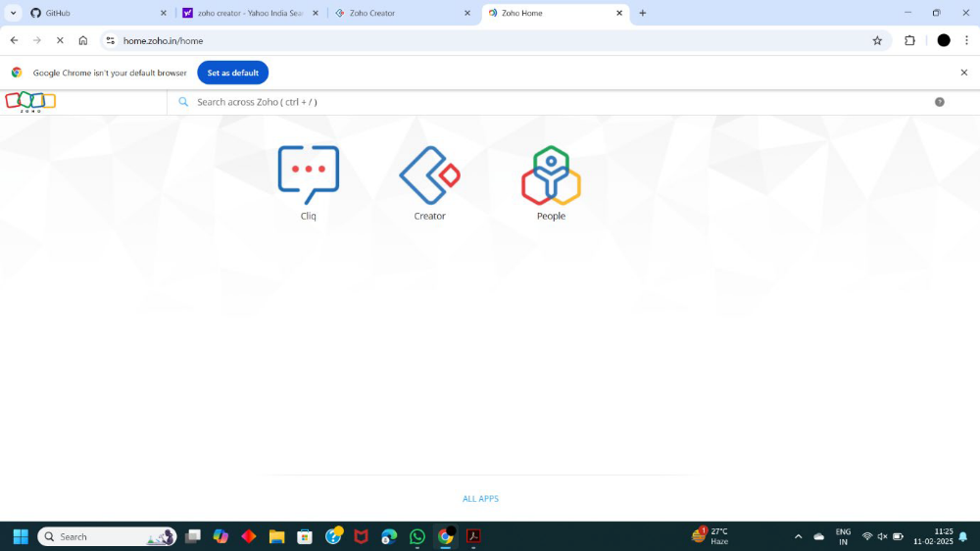
STEP 3: CREATE APPLICATION NAME
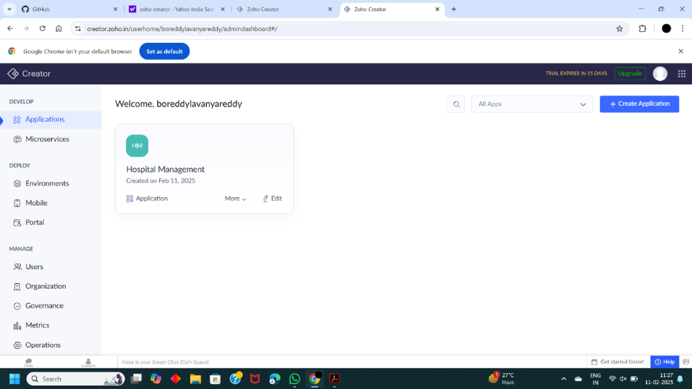
STEP 4: SELECT ONE FORM AND GIVE FORM NAME
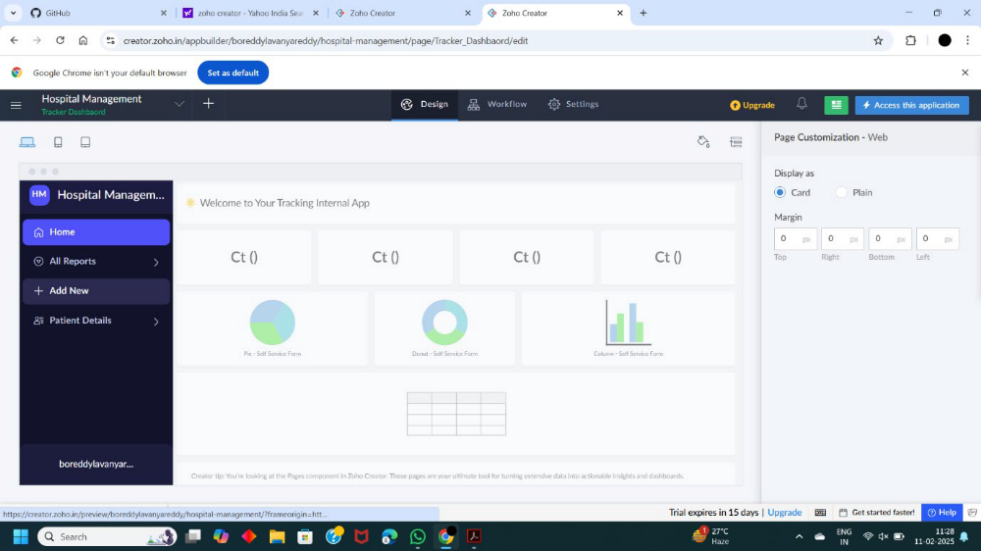
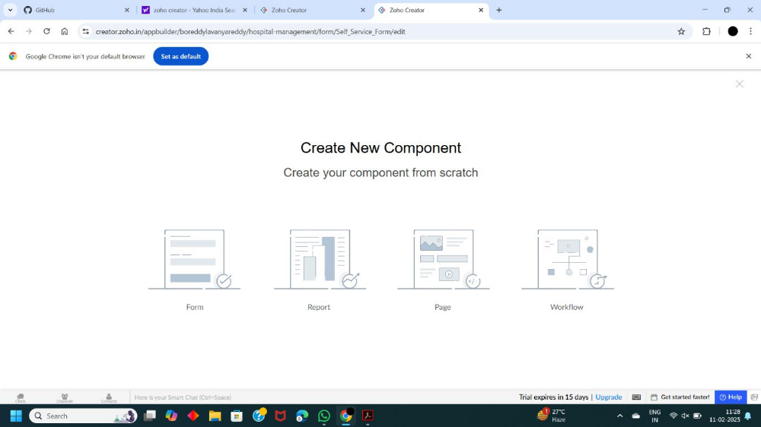
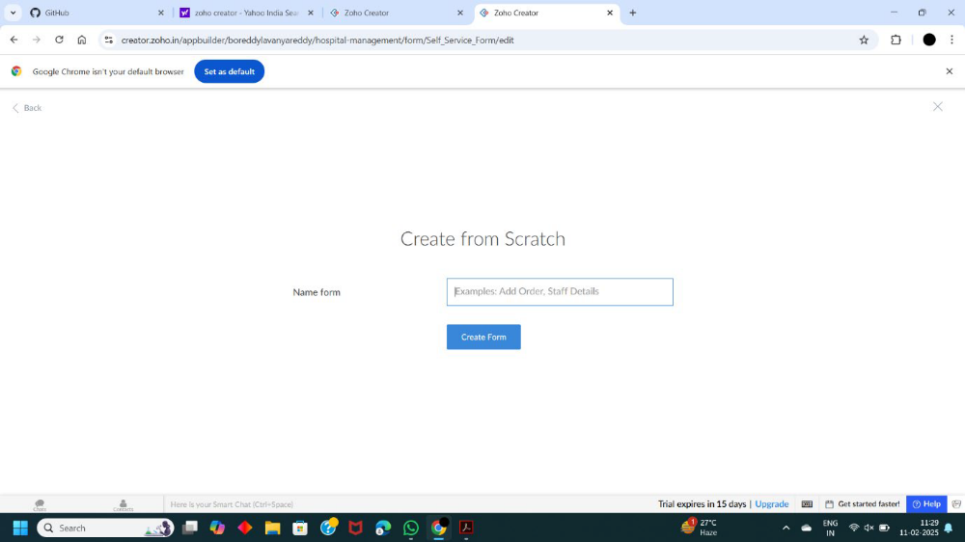
STEP 5: DRAG AND DROP THE DETAILS
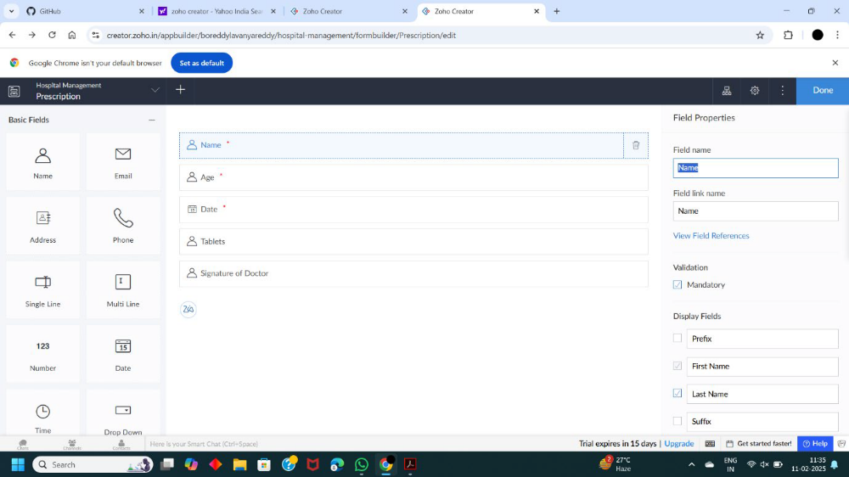
STEP 6: ENTER ALL DETAILS IN THE FORM AND GIVE SUBMIT
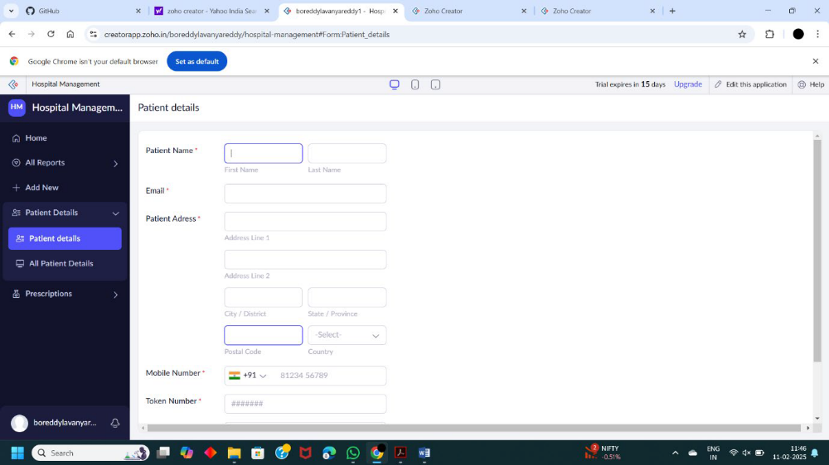
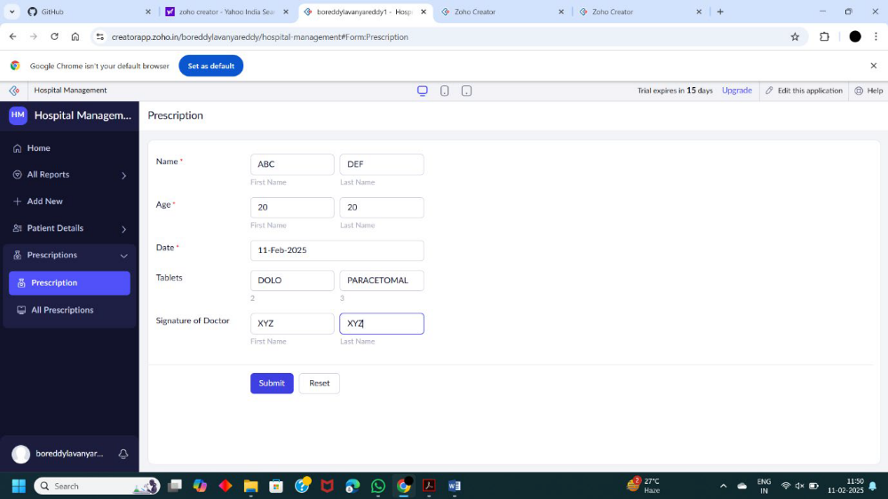
STEP 7: CLICK ON ALL DETAILS AND CHECK FOR THE DETAILS.
